Annual Conference 2015  Committed to Excellence  Tuesday 10th November 2015  Hilton Glasgow Hotel, 1 William Street, Glasgow G3 8HT | 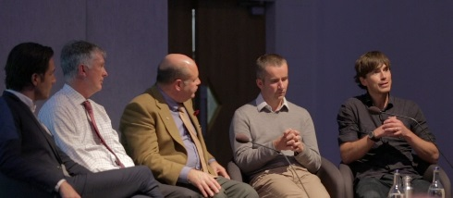

OUTLINE PROGRAMME

Monday 9th November 2015
From 9pm: An opportunity to network with friends and colleagues the evening before
- Location within Glasgow Hilton Hotel: TBC

Tuesday 10th November 2015

ALL SESSIONS WILL BE FACILITATED BY:

Willie Cameron

Director of Visit Loch Ness; Director of Highlands & Islands Tourism Awards and Founding Director of The Cobbs Group

9.30am – 11am | Registration, Refreshments & Exhibition Viewing
10am – 10.50am | Annual General Meeting (for ASSC members only)
11am – 11.45am | Welcome Address  - David Smythe, Chairman, ASSC  Exceeding Expectations  - Nick Nairn, Celebrity Chef, Nick Nairn Enterprises  SESSION ROUND-UP with Q&A - Willie Cameron
11.45am – 12.30pm | Marketing Scotland: The Next Chapter 2016  - Charlie Smith, Marketing Director, VisitScotland  SESSION ROUND-UP with Q&A
12.30pm – 1.45pm | Lunch & Exhibition Viewing
1.45pm – 3pm | What’s New to Service Provision?  - Find Your Place in Social Media: Ali Campbell, Marketing, Association of Scotland’s Self-Caterers  - Right Message, Right Time: Excellence in the Online Customer Journey: Joel Lumsden, Head of SEO / Organic Marketing, Attacat Ltd  - It Was So Much Better Than I Thought It Would Be: Paul Saunders, Paul Saunders Media  - Economic impact of holiday rentals in Spain: Pablo Zubicaray, Presidente, Fevitur (Spanish Holiday Home Trade Association)  - Homelands - A Break By the Sea with Access for All: David Paton, Development Coordinator, Homelands Trust Fife  SESSION ROUND-UP with Q&A - Willie Cameron
3pm – 3.30pm | Refreshment Break & Exhibition Viewing
3.30pm – 4pm | Expending Horizons and Innovation  - Cathy Craig, Commercial Director of Abellio Scotrail  SESSION ROUND-UP with Q&A - Willie Cameron
4pm – 4.30pm | Question Time: Your Questions Answered with Our Expert Panel  Chaired by: Willie Cameron  - David Smythe, Chairman ASSC  - Fiona Campbell, Chief Executive, ASSC  - Nick Nairn, Celebrity Chef, Nick Nairn Enterprises  - Cathy Craig, Commercial Director, Abellio Scotrail  - Charlie Smith, Marketing Director, VisitScotland  - Marc Crothall, Chief Executive, Scottish Tourism Alliance  - Pablo Zubicaray, President, Fevitur  - Martin Sansone, Chief Executive, MyRentals Ltd  Closing Remarks  - Fiona Campbell, Chief Executive, ASSC

