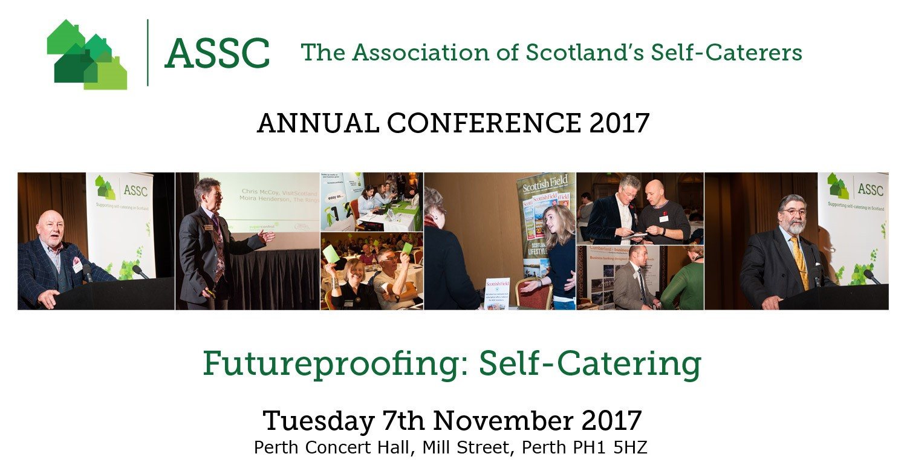

OUTLINE PROGRAMME

Monday 6th November 2017
From 9pm: An opportunity to network with friends, colleagues and industry representatives
Location: The Bothy, 33 Kinnoull Street, Perth PH1 5EN
Drinks Reception Sponsored By 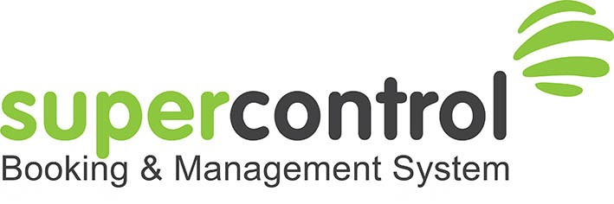

SuperControl is sponsoring the pre-event drinks reception the night before the main ASSC Conference. It’s the perfect networking opportunity for both existing clients, and those interested in finding out more. Join us at this informal evening, you can:
• meet the SuperControl team
• find out what’s new and what we’ve got in the pipeline
• get expert advice (including best practice tips) in an exclusive Q&A training session
- Free prize draw

Tuesday 7th November 2017
Our Host will be Willie Cameron, Director of Visit Loch Ness; Director of Highlands & Islands Tourism Awards and Founding Director of The Cobbs Group
9.30am – 11am | Registration, Refreshments & Exhibition Viewing  - Supported by Perth & Kinross Council
10am – 10.50am | Annual General Meeting (for ASSC members only)
11am – 11.30am | Opening of Conference  Welcome Address  - David Smythe, Chairman, ASSC  Welcome from Provost of Perth & Kinross  Provost Dennis Melloy, Perth & Kinross  Welcome Address  - Dr Alasdair Allan, Minister for International Development and Europe, The Scottish Parliament  Session Round-Up with Q&A – Willie Cameron
11.30am – 12 noon | How to Encourage Your Guests to Return Again & Again  Jackie McCamon, Customer Support Specialist, SuperControl  Katie Stovell, Marketing Consultant, Super Control  Session synopsis:  - Are you making the most of the data in your booking software?  - Understanding the behaviour of repeat guests will help you make better business choices, and ultimately improve your guests’ experience.  - When you personalise a guests’ experience at every stage, they get a holiday tailored just for them – without having to search for it. It saves them time, makes them feel valued and validates their loyalty.  You benefit because it gives guests a reason to book direct instead of through one of the big booking websites. It increases upselling opportunities, maximises profits, encourages return visits and can turn your guests into champions of your holiday cottage.  Session Round-Up with Q&A – Willie Cameron
12noon – 12.30pm | Dealing With the Certainty of Uncertainty  Malcolm Roughead, Chief Executive, VisitScotland  Session Round-Up with Q&A – Willie Cameron
12.30pm – 1.45pm | Lunch & Exhibition Viewing
1.45pm -2.30pm | Economic Impact  Self-Catering: Economic Impact  Henry Bankes, Head of Legal Affairs, Wyndham Destination Network EMEAI  Speaker Synopsis:  An overview of the self-catering sector in the UK, the challenges and the opportunities, and an introduction the ASSC’s Economic Impact Study.  The European Perspective  Carlos Villaro Lassen, Secretary General, European Holiday Home Association  Speaker Synopsis:  A look at some of the challenges and opportunities faced by our European counterparts and an update on the European Commission Study into short-term rental regulation.  Session Round-Up with Q&A – Willie Cameron
2.30pm – 3pm | Refreshment Break & Exhibition Viewing
3pm – 4pm | Industry Updates – What You Need To Know….  Financing Your Self Catering Business – Working With Your Lender to Achieve Your Objectives  Grant Seaton, Senior Business Lending Manager, Cumberland Business, Cumberland Building Society  Speaker synopsis:  Financing the business is likely to be one of the principal costs of the enterprise so select your partner with care. Expect a lender to ask lots of questions (and if they don’t maybe they aren’t properly engaged). Expect to provide an asset/liability summary plus an IEP. SWOT analysis? Even if you have owned the business for 10 years prepare a high level Business Plan outlining what you’ve achieved and where you intend to take the business. High quality pictures are often more powerful than lots of prosaic comments.  Anticipate key questions such as  - What is your USP?  - How do you keep abreast of developments in your market?  - How slick is your website? Are you in-tune with Social Media?  - Who are your competitors and how do you compete (eg price, facilities…..)? If there is an absence of local letting agents does that tell you something (eg demand may be absent)?  - What is your target demographic (eg Young families with kids, Grey Pound, hardy outdoor types…..)?  Grant will talk further about taking/getting advice when selecting your funding partner; what obstacles might be in the way; considering expansion and what might be expected.  Inheritance Tax and Business Property Relief - What You Need to Know to Protect Your Future  Brian Wright, FBD Consultancy (Scotland) Ltd - Business Growth Specialists & Chartered Accountants  Speaker Synopsis:  Brian will give a general introduction into the world of success as well as cover  - Tax as a cost and our attitude to tax  - An introduction to inheritance tax  - The difficulty with property  - A possible strategy for working within the tax rules to mitigate its effects  Cyber Crime – What It Means To You  Keith McDevitt, Cyber Resilience Integrator, Defence, Security and Cyber Resilience Division, Safer Communities Directorate, Scottish Government  Speaker Synopsis:  Keith’s presentation will cover the evolution of internet enabled criminality and provide the audience with some key advice on how they can minimise the risk by taking some simple steps which will enable them to enjoy the business benefits of operating in an online world  Session Round-Up with Q&A – Willie Cameron  David Smythe, Chairman, ASSC
4pm – 4.45pm | The 7 Step Formula to Propel Your Profits - To Get You Earning More From Your Holiday Home  Karen Spencer, Founder of The Business Of Holiday Rental  Speaker Synopsis:  Karen will outline her 7 step Holiday Rental Success Formula, all of which are just as important as each other. You need to apply the knowledge and techniques covered in all 7 steps to move your holiday rental business forward and maximize your income.  Step 1 - Your Guest – So you think you know who your guests are or you don’t really care who your guests are?? Well this one is super important.  Step 2 - The Product – You love your holiday home and it’s time to let the world know just how bloomin' gorgeous it is too!  Step 3 - The Experience – This is more than just a rental isn’t it!  Step 4 - Visibility – If you blend in then, guess what, you blend in. It’s time to be loud and proud about what you have to offer.  Step 5 - Going Pro – I know you love it and I know that it’s more than a business BUT I don’t want you to have an expensive hobby. I want you to have a sustainable business that not only financially recompenses you but that’s REALLY rewarding too!  Step 6 - Relationships – They are more than just names on a booking form aren’t they! These people might come back year on year, your property could be part of some people’s lives as much as it’s a part of yours. Let’s explore the customer journey, email marketing, the booking cycle, building relationships, gathering social proof and what to do with it.  Step 7 - Momentum – No point in just doing this in the short term, let’s make it fabulous and sustainable. I am going to show you how to keep up what you've just learnt and what do you need to do differently depending on the time of year.  Come along and hear how Karen’s excellent presentation – not to be missed.  Session Round-Up with Q&A – Willie Cameron
4.45pm | Closing Remarks  - Fiona Campbell, Chief Executive, ASSC
