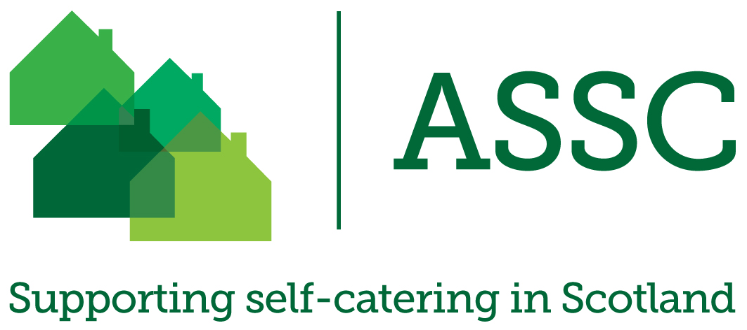
Dear Cabinet Secretary,

As Chief Executive of the Association of Scotland’s Self-Caterers, the only trade body representing the interests of the traditional self-catering sector, I am contacting you regarding the issue of Energy Performance Certificates (EPCs) and their application to short-term holiday let properties in Scotland. This is a matter of deep concern to our members.
Further to the points made in our response to the Scottish Government’s consultation, Energy efficiency and condition standards in private rented housing, which you can find attached, we are of the view that an exemption should be granted for short-term holiday lets in terms of compliance with EPCs, as occurs in England.
Moreover, several of our European neighbours – including Italy, Denmark, Sweden and Germany – have all introduced exemptions, approved by the European Commission, for holiday lets in terms of energy performance improvements under the Energy Performance of Buildings Directive 2010/31/EU. We therefore seek a return to guidance that holiday lets do not require an EPC (withdrawn in 2012, but not announced until 2017), to ensure that there is a level playing field for operators throughout the United Kingdom, as well as the European Union, so that operators in Scotland are not unfairly disadvantaged.
The imposition of EPCs will increase operating costs for our members. We remain perplexed as to why the Scottish Government are imposing an onerous extra burden on our sector when other countries are interpreting the exact same EU Directive and exempting holiday lets from EPCs.
We have previously engaged the Minister for Local Government and Planning Kevin Stewart MSP, as well as the Scottish Government’s Building Standards Division, but were disappointed with the responses received. In your capacity as Cabinet Secretary for Tourism, and as someone with an understanding and appreciation of the importance of our sector to the Scottish economy, we implore you to use your influence to stand up for our industry within government.
As outlined in the Frontline Consultants report, The Economic Impact of Short-Term Letting on the Scottish Economy, self-catering provides a huge contribution to the Scottish economy. In addition to supporting over 15,000 jobs, it attracts over £720m in consumer spending, £470m of which is spent by visitors to Scotland. At a time when we should be looking to grow our tourist economy to meet Tourism Scotland 2020 goals, applying EPCs to holiday lets defies sense.

We contend that the notion of an EPC on short-term holiday lets is impractical, unnecessary and potentially damaging to the tourist economy. We believe that the Scottish Government should be looking to maximise the opportunities for our tourist economy and not impose superfluous regulatory burdens on the holiday let industry, particularly when it already faces significant cost pressures. It surely cannot be the policy of the Scottish Government to place Scottish operators at a disadvantage compared to other countries, including England?
We would be more than willing to meet to discuss these issues in greater detail at a time and date of your convenience.
Yours sincerely,

Fiona Campbell
Chief Executive, ASSC
The Association of Scotland’s Self-Caterers
1 Invereoch Court, Arrochar Argyll & Bute G83 7AB
01462 894 483 www.assc.co.uk administrator@assc.co.uk

http://www.assc.co.uk/download/ASSC_Economic_Impact_Assessment_of_Short_Term_Lettings_on_the_Scottish_Economy_-_Final_Report_v1.3.pdf

