# 

# Fire Risk Assessment Template

This template is designed to help a responsible person carry out a Fire Risk Assessment for well-managed small bed and breakfast and self-catering premises and applies to:

* premises used for self-catering holidays if occupied by not more than 10 persons
* bed and breakfast premises in the home of a resident operator (for not more than 8 guests)

and which in either case, have a means of escape from bedrooms via a traditional ‘hall’ with at least one exit directly to the outside; do not have letting or guest accommodation below a ground floor or above a first floor; do not act as the principal residence for paying guests; and do not have any storey area over 200m2 internal floor space.

It also applies to holiday cottages, caravans, camping and glamping pods, bothies, lodges, shepherds’ huts, tents, tree houses and yurts.

The responsibility for complying with the fire safety duties in premises which provide sleeping accommodation sits with the employer and/or other persons who operate or have control of the premises to any extent. This might include managers, landlords, owners and staff

If you feel unable to interpret this guidance, you should seek assistance from someone with technical knowledge. The SFRS as an enforcer of the legislation, cannot undertake a duty-holder’s risk assessment obligation. Though it has a statutory requirement to provide general advice on request about issues relating to fire safety and should be able to provide information and advice which will assist duty-holders to understand their obligations under the law.

If you do not have the time, relevant expertise or confidence to carry this out adequately, seek advice from an accredited fire risk assessor.

This should be read in conjunction with

# [Fire safety guidance for existing premises with sleeping accommodation](https://www.gov.scot/publications/practical-fire-safety-guidance-existing-premises-sleeping-accommodation/)

* [Fire safety guidance for existing premises with sleeping accommodation: Small Bed and Breakfast and Self-catering Premises](https://www.gov.scot/publications/practical-fire-safety-guidance-existing-premises-sleeping-accommodation/pages/12/)
* [Do You Have Paying Guests Guide.](https://www.gov.uk/government/publications/do-you-have-paying-guests) This utilises English legislation, however the guidance and principles can still be applied to meet Scottish legislation.

**A Risk Assessment should be reviewed annually, or at an earlier time if there is reason to suspect that it is no longer valid or there has been a significant change in the matters to which it relates.**

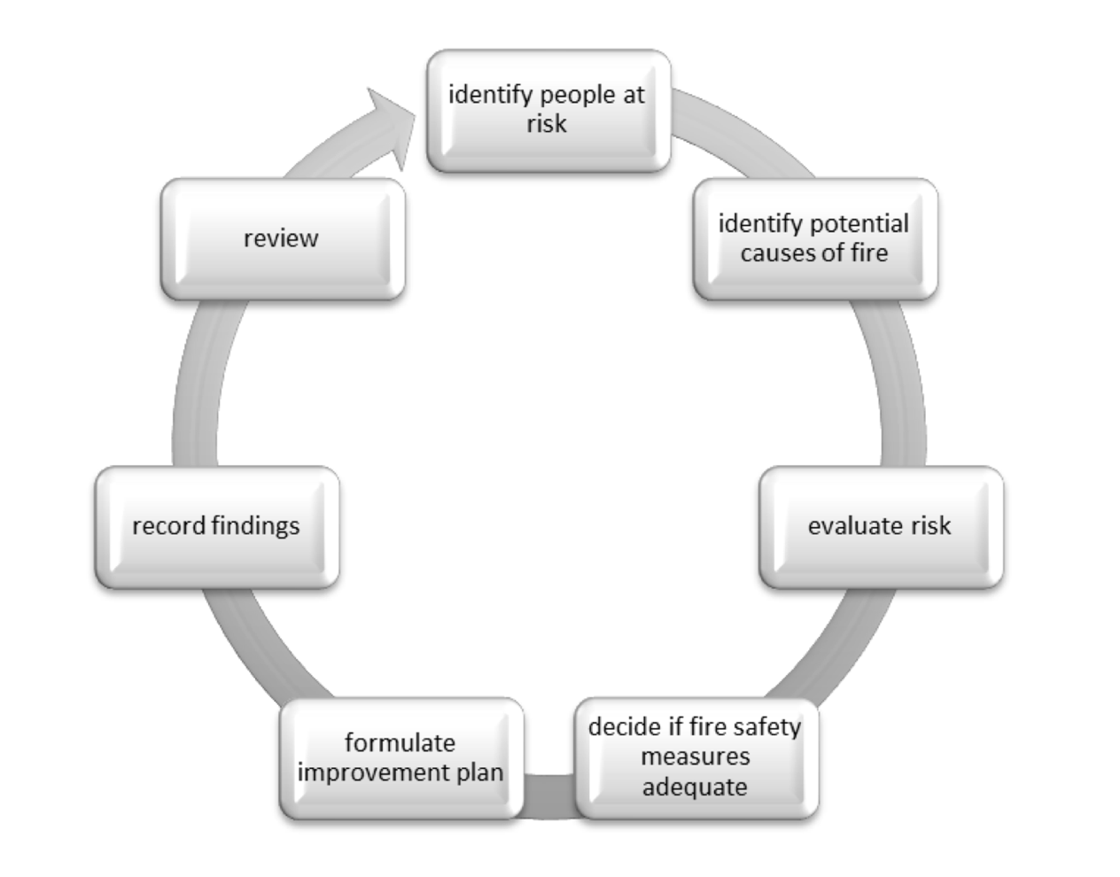

**Fire Safety Risk Assessment Process[1]**

Walk around your premises. Look at them from a fire risk point of view[2]: -

1. Who could be harmed? Consider the risk to people, particularly any vulnerable groups such as young persons, the elderly or visitors unfamiliar with the premises
2. Identify hazards and how people could be harmed e.g. by being overcome or trapped by fire or smoke, burned, unable to escape due to locked fire exit doors etc
3. What existing fire safety measures are provided? Compare existing fire safety measures against recognised benchmarks contained in guidance documents, such as those published by the Scottish Government, and decide whether your existing fire safety measures for the premises are adequate or are additional measures necessary?
4. Record the significant findings of your fire risk assessment. Prepare an action plan, prioritise actions, and allocate deadlines and responsibilities for implementation.
5. Make arrangements for regular review of the risk assessment.

**Fire Risk Assessment**

|  |  |
| --- | --- |
| **Address of property assessed:** |  |
| **Name and position of person undertaking the assessment:** |  |
| **Date of assessment:** |  |
| **Number of floors/area:** |  |
| **Use of property:** |  |

## Identify people at risk

The next step in the fire risk assessment process is to consider the people who might be at risk from a fire in your premises and record this information.

### Identify people at risk

List all of the people potentially at risk from fire, including staff, guests and contractors.

**Guests**

Consider both the numbers and types of guests you would expect to accommodate.

1. How many guests can your premises safely accommodate?
2. Do you anticipate that children will stay in the property and, if so, how many and where will they be?
3. Do you anticipate accommodating people who require assistance to escape the property (e.g. disabled people, those with a respiratory condition, physical injury or other temporary impairments)?
4. Are any staff on site to oversee or assist in an evacuation? If not, consider any additional measures that may be required for those not familiar with the premises.

*Add information on those potentially at risk here.*

### Number of staff and employees

1. Consider the number of employees and their ability to escape.
2. Consider other people who may work on the site, such as contractors and cleaners.
3. Are there any employees under 18? If so, the risk assessment will need to take into consideration the inexperience, lack of awareness of risks and potential immaturity of young people.

*Add information on those potentially at risk here.*

## Identify fire hazards and fire risks

For a fire to occur, three key components need to be present:

1. Heat - this is an ignition source, such as a flame from a match or spark from defective wiring
2. Fuel - this is something that can burn, such as wooden furniture, paper etc.
3. Oxygen - this is in the air that is all around us

It is useful to keep this in mind when carrying out a fire risk assessment.

To the best of your knowledge, answer the questions relating to relevant items. To assist you, a number of common sources of ignition are listed below.

### Identify sources of ignition in your premises

You can spot fire hazards in most buildings if you systematically list both the sources of ignition and fuel that are there. Apply your own good judgement in deciding whether or not there is a real risk of an unwanted fire. With the combinations of fuels and ignition sources, is there a risk of an unwanted fire and are there any particular activities that could give rise to an increased risk of fire?

1. What are the sources of ignition in your premises? Identify what might cause a fire in your property.
2. What fuels are present and where are they? Identify what there is to burn in your property (including furniture, textiles and fabric).
3. Are other heat sources such as light bulbs or lamps situated close to combustible materials?

*Add information on sources of ignition here.*

**Electrical wiring and appliances**

1. Has electrical wiring been checked by a qualified contractor within the last five years? Are there any signs of damage?
2. Have trailing cables, overloaded sockets / adaptors / extension leads, damage to cables and scorched, cracked or loose sockets and switches been eliminated?
3. Are the fuse board and circuit breakers in good condition and correctly labelled?
4. Are all appliances in good condition and subject to a suitable test and inspection regime?
5. Are washing machines, tumble dryers and other white goods clean and in good working order? Are lint filters cleaned regularly?
6. Have the appliances been registered with the manufacturer or checked against current recall lists? You can [register your appliances online](http://www.registermyappliance.org.uk).
7. Are appliances checked between lets, to ensure no damage happened during the previous let?

Guidance on electrical safety, including FAQs on maintaining portable appliances, is available on the [HSE website](http://www.hse.gov.uk/electricity).

*Add information on electrical wiring and appliances here.*

### Cooking

1. Are there instructions for the safe use of cooking equipment?
2. Have gas appliances been checked and serviced by a Gas Safe registered engineer?
3. Is equipment (particularly where fitted with extraction hoods and vents) regularly cleaned and free from grease?

*Add information on cooking equipment here.*

### Smoking

1. Smoking is a regular cause of fire and results in more fatalities than any other cause.
2. Is there a strict ‘no smoking’ policy, or is smoking allowed in some bedrooms in serviced accommodation or in bedrooms and public areas of self-catering units? Is this limited to vaping or e-cigarettes?
3. Are sufficient ashtrays available and are they regularly emptied into a safe bin (for example, a metal one)?
4. It is recommended that smoking is not permitted or is only allowed in well-defined and protected smoking areas.

*Add information on your smoking policy here.*

### Candles

1. Candles and tea lights are a regular cause of fire and fatalities.
2. It is recommended that candles, tea lights and ethanol burners are not provided and that there is a policy prohibiting their use.

*Add information on candles / your naked flame policy here.*

### Heaters and boilers

1. What sort of heating is there in the property?
2. Are all heaters in good condition?
3. It is recommended that if freestanding heaters are provided, they are low risk (oil-filled radiators, convector, halogen or fan heaters) due to the risk of fire.
4. Is the boiler regularly serviced by a qualified person?
5. Carbon monoxide detectors must be provided where living accommodation contains a gas or solid fuel burning appliance.

*Add information on heaters and boilers here*

### Open fires and burners

1. Is a fireguard provided?
2. Is the chimney regularly swept?
3. Are spark arrestors or bird guards provided, where needed (for example, properties with a thatched roof)?
4. Is the hearth adequate to prevent rugs and fabrics touching hot surfaces?
5. Are dry wood, kindling and firelighters provided and stored a safe distance from heat and hot surfaces?
6. Are metal ashbins provided?
7. Are appropriate instructions given and procedures in place?
8. Working carbon monoxide detectors must be provided where living accommodation contains a solid fuel burning fire.

*Add information on open fires and burners here.*

### Elements of structure

1. Are there any wall or ceiling lining materials, other than wallpapers, that might burn (such as polystyrene ceiling tiles, wood effect or wooden cladding)?
2. If downlighters have been provided in ceilings, do they have inbuilt intumescent protection?
3. Consider other combustible materials associated with any provided glamping pods, camping materials, tree houses, balconies etc.

*Add information on elements of structure here.*

### Furniture and furnishings

1. Does upholstered furniture within the premises comply with the Furniture and Furnishing (Fire) (Safety) Regulations 1988?
2. Is any upholstered furniture damaged with internal filling exposed?

*Add information on furniture and furnishings here.*

### Domestic waste

1. Is it removed from the property regularly?
2. Is it kept away from sources of ignition?
3. Is it stored away from premises, especially away from windows and exits?
4. Are further measures required, such as locks or metal bins?

*Add information on domestic waste here.*

### Other items – e.g. petrol for lawnmowers, cleaning materials etc.

1. Are any highly flammable liquids or substances kept on the premises? If so, they must be stored outside in locked metal bins or storage. Guests must either be restricted from using these or instructed on their safe use.
2. Are liquid propane gas barbecues or patio heaters provided? If so, they must only be used outdoors (not on balconies) and instructions for their use must be provided.
3. Are there any linen stores or towel closets near heat sources?

*Add information on other items here.*

### Activities that might cause a fire, including work processes and procedures

The most common causes of fire are: cooking, electrical cabling, domestic appliances, smoking materials (including matches and lighters) and heaters.

While some of these issues will have already been considered above, it is worth spending a few moments to think about your particular circumstances and what else might create a risk of fire in your premises. Consider what you could do to either remove or reduce these risks. For example, many owners of heritage buildings prohibit contractors using tools such as blowlamps on their premises.

In addition, you need to remember that guests are not familiar with the premises, nor the particular appliances and equipment on site.

*Add information on activities that might cause a fire here.*

### Other

Are there any other sources of ignition in your property?

*Add information on any other sources of ignition here.*

## Evaluate the risks

With all the aforementioned aspects considered, the levels of risk can be established and simple 'common sense' measures taken to reduce them. However, the law still expects you to plan for a fire occurring, ensure that it is detected and people are warned and then able to escape.  
  
For most small buildings the fire precautions should be fairly basic. You should note, however, that buildings built to domestic requirements have different standards to those built for commercial purposes (e.g. emergency lighting, open plan layout, escape windows), so you may need to factor in additional measures if a private dwelling is being used for short-term accommodation.

### The fire detection and alarm system

Describe what fire detectors and alarm systems have been provided.

1. Is the fire detection and alarm system in the premises adequate to provide sufficient early warning?
2. Have you considered detection and audibility in high-risk and sleeping rooms?
3. How will deaf people or people with hearing loss respond to a fire alarm?
4. How regularly is your fire detection and alarm system tested and maintained?

*Add information on the fire detection and alarm system here.*

### Means of escape – detail the type of property

1. What sort of building is it?
2. How many levels does the premises have?
3. Is the premises part of a multi-occupied building?

*Add information on the means of escape – detailing the type of property here.*

### Means of escape – detail the number of exit doors and where they are

1. Are doors on the escape route always easy to open without the use of a key?
2. Are escape routes always kept clear and available for use?
3. Do the doors opening onto the escape routes provide adequate protection?
4. Does the escape route rely on any open plan areas? If so, can all people still escape safely without placing themselves at risk from fire?
5. How often do you check the escape routes?

*Add information on the means of escape – detailing the number of exit doors and where they are here.*

### Evacuation procedures

1. Describe the evacuation procedures.
2. Is the location remote and might this leave guests with difficulty in calling the emergency services?
3. Have you recorded the evacuation procedures and ensured guests are aware of them? E.g. have they been provided in the form of a fire action notice or via a welcome folder?
4. Have you considered the range of needs guests may have?

*Add information on evacuation procedures here.*

### Escape lighting

Detail areas covered by emergency escape lighting (if any). For small premises, it might be acceptable to simply provide a rechargeable torch.

1. Do you need to install any additional emergency escape lighting to help those unfamiliar with the premises to escape in an emergency?
2. Where you have provided torches, do you need to provide information to your guests?
3. How regularly do you test your emergency lighting?
4. Are outside areas well lit?

*Add information on escape lighting here.*

### Firefighting equipment

Detail what fire extinguishers and blankets are provided and where they are.

1. Where provided, is all firefighting equipment inspected and maintained regularly?
2. If fire extinguishers are provided, have staff been trained how to use them?
3. Guests should not be expected to use them. However, you may wish to provide a small multi-purpose fire extinguisher, or a fire blanket for the kitchen area.
4. If so, have they been adequately instructed in their use?

*Add information on firefighting equipment and locations here.*

|  |  |
| --- | --- |
| **Signed** |  |
| **Print name** |  |
| **Date** |  |

1. https://www.gov.scot/binaries/content/documents/govscot/publications/advice-and-guidance/2018/06/practical-fire-safety-guidance-existing-premises-sleeping-accommodation/documents/00536681-pdf/00536681-pdf/govscot%3Adocument/00536681.pdf?forceDownload=true
2. https://www.gov.scot/binaries/content/documents/govscot/publications/advice-and-guidance/2014/10/fire-safety-risk-assessment-forms-and-guidance/documents/guide-to-carrying-out-and-recording-a-fire-safety-risk-assessment/guide-to-carrying-out-and-recording-a-fire-safety-risk-assessment/govscot%3Adocument/FIRE%2BSAFETY%2BRISK%2BASSESSMENT%2B-%2BSeptember%2B2021.pdf